Machine Learning – Final Project Report

Name:

Code:

Classifying image using CNN by taking Cipar10 (Keras) dataset

**Step1: Importing necessary libraries**

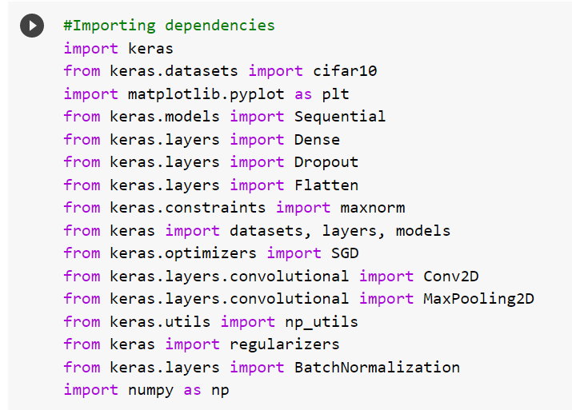

**Step 2: Performing Data processing**

* Train set has size of 50000
* Test set contains size of 10000

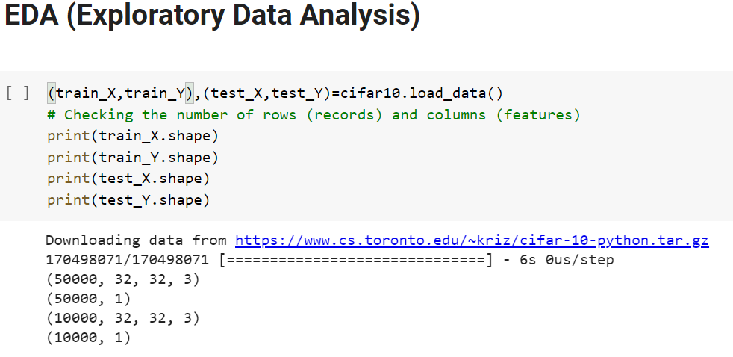



* Converting the datatype to float
* Normalizing the dataset
* Performing One-hot encoding for target label

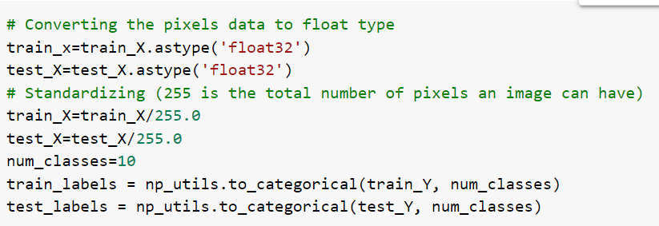

**Step3 : Building Baseline model**

The model-1 is formed using SGD as optimizer. Loss is determined using Categorical Cross entropy for 20 epochs.

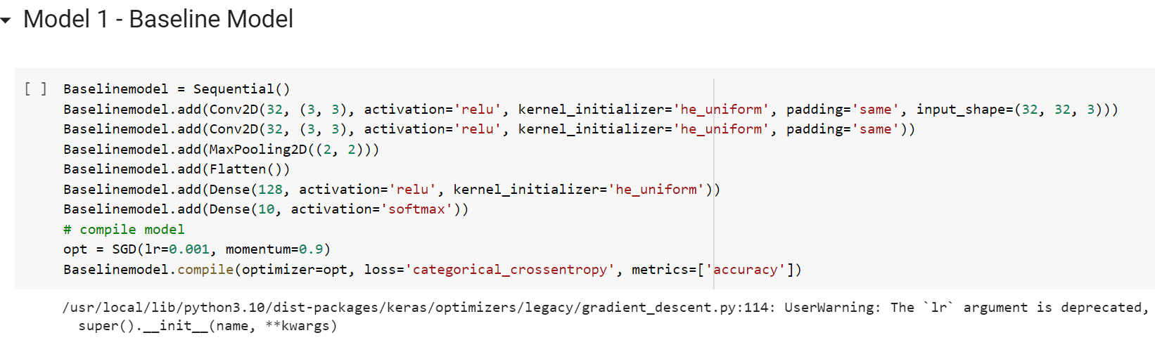



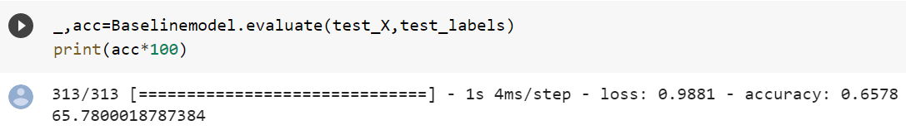

Base model built with an accuracy of 65%

**Step4: Building Model 2**

The model-1 is formed using SGD as optimizer additional by providing the learning rate . Loss is determined using Categorical Cross entropy for 20 epochs.

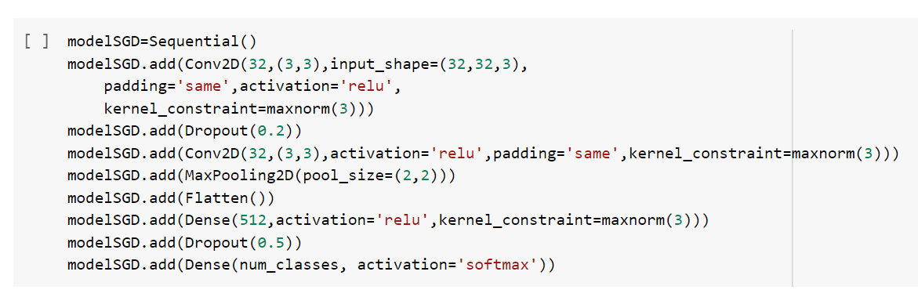

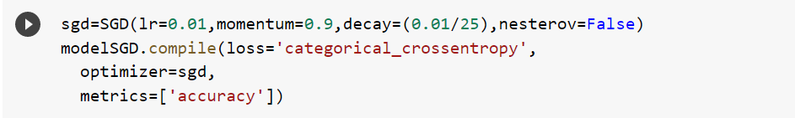



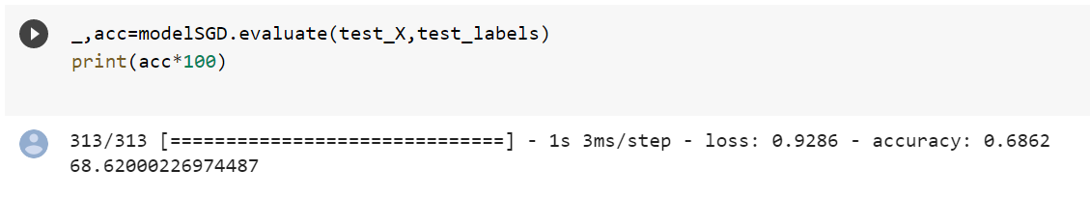

Model2 has an accuracy of 68%

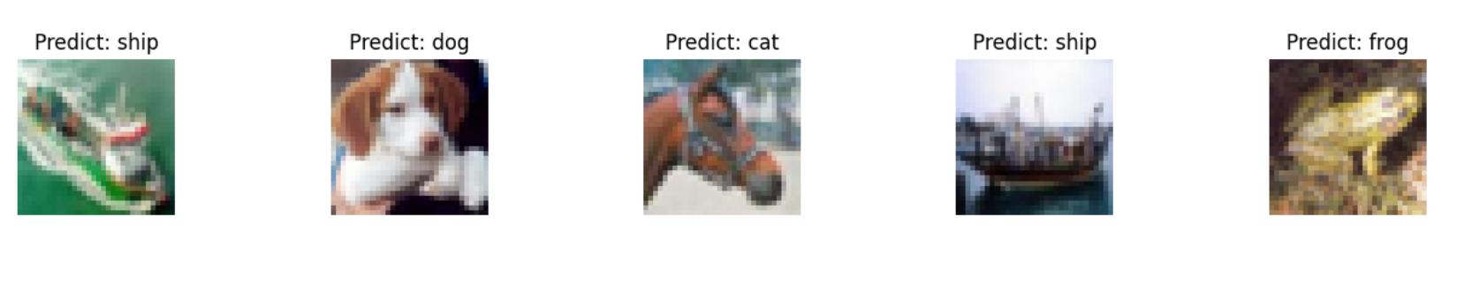

From the above sample image, we can able to see our model able to classify images some images correctly and some incorrectly

* Ship classified correctly as ship
* Dog correctly classified as dog
* horse incorrectly classified as Cat

**Step 5: Building Model 3**

The model-1 is formed using ‘adam’ as optimizer. Loss is determined using Categorical Cross entropy for 20 epochs.

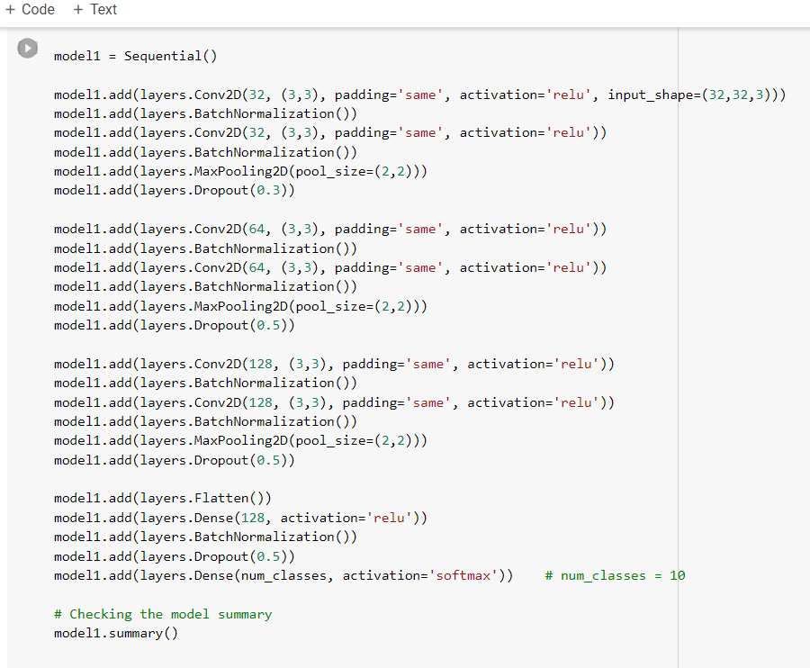





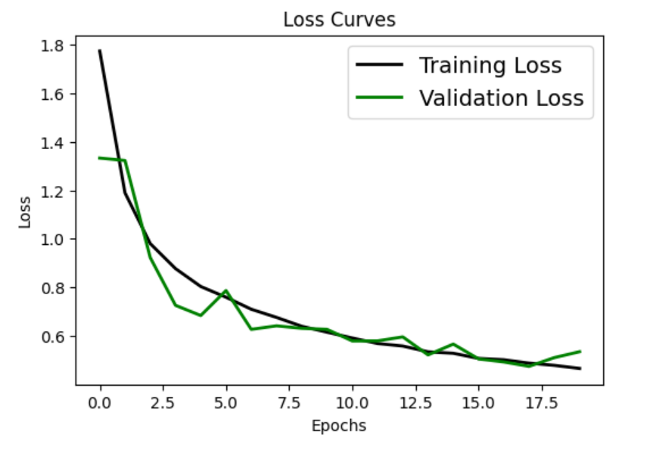 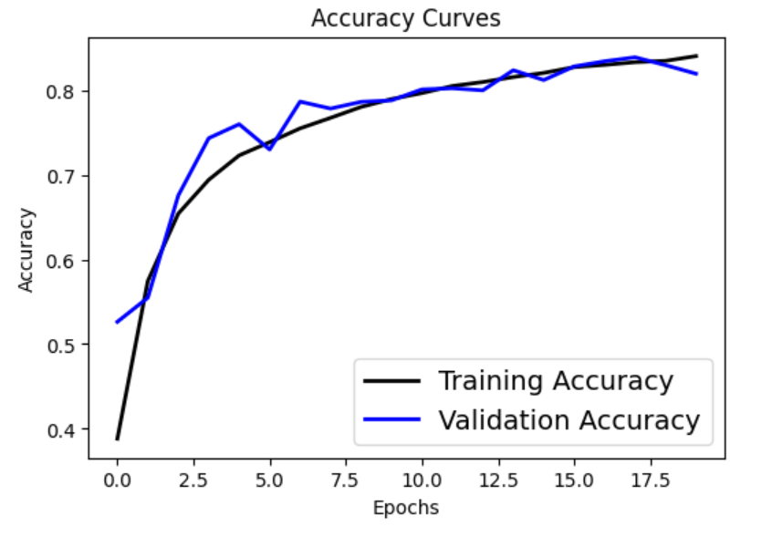

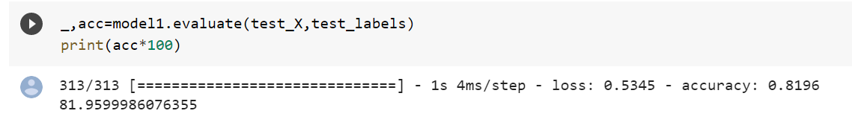

Model 3 building using adam optimizer is having 81% as an accuracy

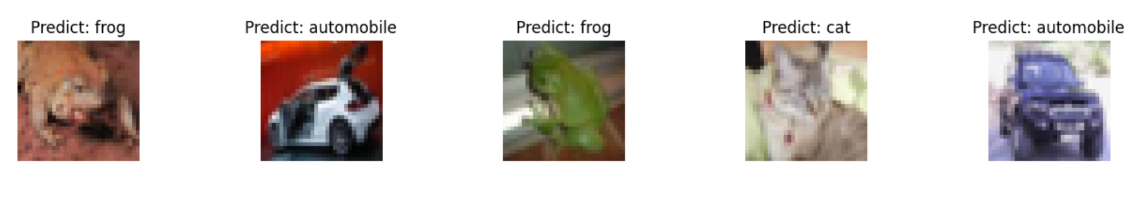

From the above image we can able to see our classified some sample images correctly.

**Step 6: Model Comparison**

From the above three model Final model was able to classify images accurately than the other two model .

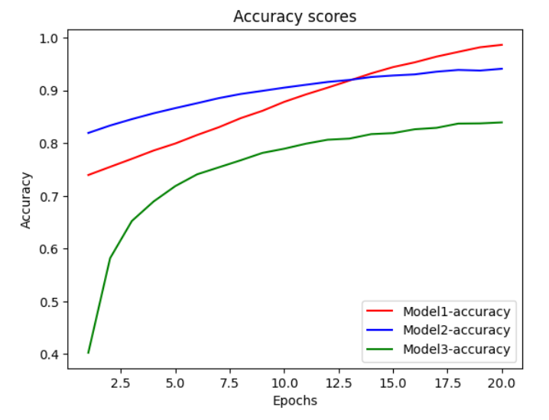 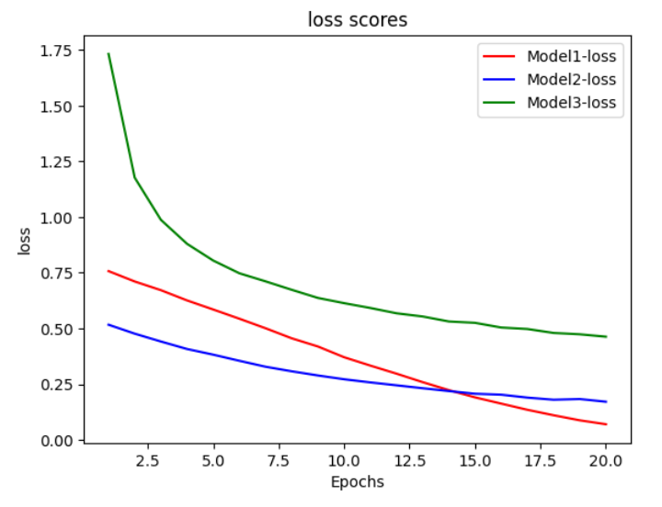

Model 3 is having higer classifying rate than compare to remaining models.